

Software Engineering Department

Braude College of Engineering

Capstone Project Phase B

**Deep Learning Model for Automated Detection of Meniscus Tears in Knee MRI Images**

**24-1-R-22**

**Supervisor:**

Prof. Miri Weiss Cohen

**Students:**

Neta Amzalag, [Neta.Amzalag@e.braude.ac.il](mailto:Neta.Amzalag@e.braude.ac.il)

Vital Marciano, [Vital.Marciano@e.braude.ac.il](mailto:Vital.Marciano@e.braude.ac.il)

[GitHub link](https://github.com/netaamz/DL-Model-for-Automated-Detection-of-Meniscus-Tears-in-Knee-MRI-Images)

Table of Contents

Abstract 3

Introduction 3

Meniscus anatomical structure 4

Methods 6

Data set 6

Data pre-processing 6

Models 7

Proposed approach 9

Convolutional Layer 9

Batch Normalization 10

Transfer learning 10

Network architecture 11

Hyperparameters 13

Research process 13

Training Process 13

Prediction 15

Results 16

Single plane model 16

Optimizing Hyperparameters on the most efficient plane 17

3 planes concatenation DenseNet model 20

Single plane model with convolution layer 22

2 planes concatenation DenseNet model with convolution layer 24

Discussion 26

Conclusion 27

User Guide 28

Preprocessing 28

Training 30

Predict 30

Maintenance Guide 32

References 33

# Abstract

Meniscal tears are a common knee injury often requiring surgical intervention, but current diagnosis methods relying on manual MRI interpretation are prone to variability. This project proposes a deep learning system for automatic meniscal tear detection using the MRNet dataset. DenseNet architecture was employed to classify tears from coronal, sagittal, and axial MRI planes. Through extensive preprocessing, including resizing and contrast enhancement, the middle slices were selected for training. The system was optimized with transfer learning, batch normalization, and hyperparameter tuning. Additionally, a multi-plane model was developed to integrate information from multiple MRI views. The final model, utilizing 17 middle slices for enhanced spatial detail, demonstrated about 60% accuracy in classifying meniscal tears.

# Introduction

Meniscal tears, a disruption in the meniscus cartilage of the knee joint, can significantly impair knee function and necessitate surgical intervention to repair or remove the damaged tissue ‎[1]. The meniscus plays a crucial role in distributing weight and absorbing shock between the shinbone (tibia) and thighbone (femur), ensuring smooth knee movement, it is one of the most frequently injured ligaments, due to its anatomical structure and function ‎[10]. Long-term consequences of meniscal removal can lead to accelerated joint degeneration and reduced mobility ‎[1], Early diagnosis and appropriate treatment are essential to prevent further damage and optimize patient outcomes it mostly common with athletes and active population ‎[10].

Accurate classification of meniscal tears is critical for determining the prognosis and guiding surgical decisions. Repair procedures, where the torn edges are sutured together, are suitable for certain tear types and locations. Meniscectomy, the removal of the damaged meniscus, is performed when tears cannot be repaired. Additionally, meniscus transplantation offers an alternative option for severe cases.

Currently, diagnosis of meniscal tears primarily relies on MRI scans interpreted by radiologists. However, inconsistencies in meniscal tear classification can hinder effective treatment planning and healing operation chances ‎[2]. Machine learning techniques, particularly deep learning algorithms, have demonstrated remarkable potential in medical image analysis tasks, including meniscal tear detection and classification.

Our research aims to address the challenges of inconsistent meniscal tear classification and provide a reliable tool for radiologists and clinicians to make informed treatment decisions. By facilitating early diagnosis and appropriate treatment, we can minimize patient pain, disability, and healthcare costs. For example, Shin et al. suggest a model that produces good results in detecting meniscus tears. However, its performance in classifying types of tears is slightly lower, achieving an accuracy of 72.23% for horizontal tears, and 72.48% for radial tears‎[5]**.** Our goal is to design an efficient DenseNet -based model for classifying types of meniscus tears

## Meniscus anatomical structure

Menisci are fibrocartilaginous structures located on the medial and lateral side of the knee joint. The medial menisci is C-shaped, while the lateral menisci is almost an O-shaped and smaller in size compared to the medial one‎[3] ,(fig. 1)‎[4]. The circumference of each crescent is thick, convex and attached to the joint capsule, whereas the inner edges are thin, concave and freely movable. Both horns of the menisci are attached to the tibia bone. Superiorly, they are concave to enhance the congruence of the joint surfaces [3].‎

Menisci can be divided into three zones, according to their blood supply. Red-red zone represents the vascular peripheral region with a rich blood supply. The inner region, known as the white-white zone, lacks blood vessels and is avascular. The red-white intermediate zone resides between the red-red and white-white zones, (fig. 2). Sharing characteristics of both. The potential for healing meniscal tears varies depending on the vascular region involved. Blood supply in the zone determines the likelihood of the tear healing ‎[3].

The menisci have several vital roles in the knee joint, as they perform few essential functions. They include load transmission, shock absorption, stability, nutrition, joint lubrication, and proprioception.

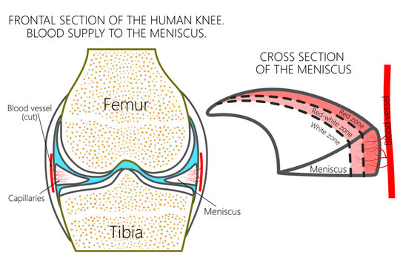However, meniscal tears are the most common knee pathology with a mean annual incidence of 66 per 100000 people. These tears have the potential to affect their main functions and the natural knee mobility. Medial meniscus tears are more common than lateral meniscal tears due to their strong attachment to the deep medial collateral ligament and joint capsule.

fig. 1 medial and lateral meniscus

fig. 2 zones of blood supply of the meniscus

In addition, the medial meniscus absorbs up to 50% of the impact within the medial compartment, making it susceptible to injury. Conversely, the lateral meniscus has greater mobility and is less firmly anchored to the lateral tibial plateau compared to the attachment of the medial meniscus.

Typically, meniscal tears are classified into groups, based on their anatomical appearance and location, (fig. 3). According to the ISAKOS classification, meniscus tears can be described based on the various tear patterns. The classification includes: vertical longitudinal, horizontal, radial, flap and complex tears. Meniscal tears can also be categorized as either partial or full-thickness‎[3]. The location of the menisci and its shape with the different types of tears affects the selected treatment method, therefore a precise diagnosis method is crustal for effective healing process ‎[5].

There are several methods to identify meniscus tears including the McMurray Test, Apley’s Compression Test, and imaging methods. Magnetic resonance imaging (MRI) is the modality of choice for meniscal tear as it provides information for both diagnosis and surgery ‎[6] (fig. 3).

Due to its superior soft tissue contrast, MRI is highly accurate in detecting meniscal tears. Compared to arthroscopy, MRI shows 93% sensitivity and 88% specificity for medial tears, and 79% sensitivity and 96% specificity for lateral tears, making it a preferred diagnostic tool in contemporary practice in addition MRI is noninvasive tool comparing to arthroscopy ‎[7].

The diagnostic accuracy of MRI scans in identifying the presence and type of meniscal tears varies significantly between specialists in knee pathology and other medical practitioners ‎[5]. This discrepancy underscores the challenge in precisely locating and interpreting meniscus tears from MRI images. Developing a system to assist in the interpretation of knee MRI scans would greatly support clinicians in effectively managing patients suspected of meniscal tears.

Hence, the challenges that associated with the identification of meniscal tear and the leak of a system that detect a tear with high accuracy, we want to perform an automatic segmentation to identify meniscal tears in order to support doctors in the diagnosis process and even replace radiologists.



fig. 3 types of tear viewed in MRI

# Methods

## Data set

The MRNet dataset consists of **1,250** knee MRI exams in np-array format performed at Stanford University Medical Center including **508 meniscal tears** labels were obtained through manual extraction from clinical reports‎[14].‎ Examinations were performed with GE scanners (GE Discovery, GE Healthcare, Waukesha, WI) with standard knee MRI coil and a routine non-contrast knee MRI protocol that included the following sequences: coronal T1 weighted, coronal T2 with fat saturation, sagittal proton density (PD) weighted, sagittal T2 with fat saturation, and axial PD weighted with fat saturation. A total of 775 (56.6%) examinations used a 3.0-T magnetic field; the remaining used a 1.5-T magnetic field. [14].

## Data pre-processing

The dataset contains s x 256 x 256 images. Since middle images are the most useful, middle slices in the MRI sequence, 2 different depth war tested, s=3 which included the 3 middle slices, or 17 which is the minimum depth of the scans in the data set. As suggested by V. Couteaux et al. (2019) ‎[9] to apply white top hat filter on the MRI images which enhance the visibility of the meniscal tear. In order to improve the model accuracy, we used the filter with 10x10 size kernel. This morphological operation enhances the contrast of small features, such as the meniscus, against the surrounding tissues, making them more discernible for the convolutional network.

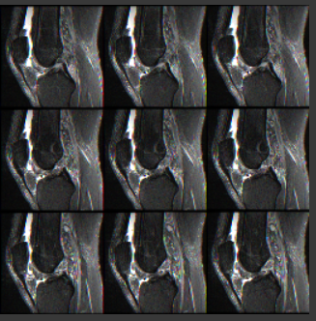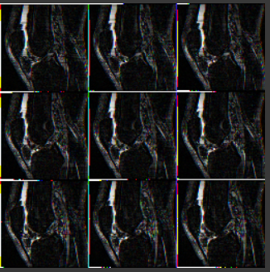

(b)

(a)

fig. 4 (a) Raw MRI scan, (b) MRI scan post applying white top hat filter with 10x10 kernel size

### Convolution Layers

A convolution layer is a major element of CNN architecture which consists combination of linear and nonlinear operations, convolutional operations and activation function. The convolutional operation is a fundamental building block of Convolutional Neural Networks (CNNs), especially for analyzing grid-based data like images. It acts like a feature extractor that takes advantage of the spatial structure within the data. Its procced with a small filter. At each location, the filter essentially multiplies its elements with corresponding elements in the input data and sums the products. This captures the presence and strength of specific features within that local area. The resulting value is placed in a new output feature map. The filter then moves on (strides) and repeats the process, building a complete feature map‎[12]. The filter size determines the size of local area that is analyzed, filter depth allows for learning different features through multiple stacked filters, stride controls how much the filter moves after each operation, and padding with zeros can be used to manage the output size and prevent information loss at the edges.

### Pooling Layer

Pooling layers delivers downsampling operation which reduces the dimensions of the feature maps, this allows reducing model complexity and computation needs. This also forces the network to focus on the most important features. Additionally, pooling layers introduce translation invariance by summarizing local information, making the network less sensitive to small shifts in the data. Unlike convolutional layers, pooling layers have no learnable parameters, but rely on hyperparameters like filter size and stride to control their behavior.

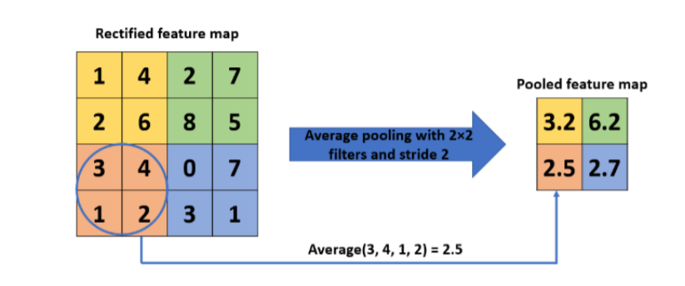

fig. 5 Example of average pooling

## Models

### Densely Connected Convolutional Networks (DenseNets)

As CNNs become deeper, they face challenges related to information and gradient flow. Long chains of layers can lead to vanishing gradients or information loss, affecting the network's ability to learn effectively. Dense Convolutional Network (DenseNet) is a type of deep learning architecture specifically designed to address some challenges faced CNNs ‎[11]. The key feature of DenseNet is its dense connectivity pattern, where each layer is connected to every other layer with the same feature-map size in a feed-forward manner within a dense block, there are $\frac{L\left(L+1\right)}{2}$ connections in an L-layer network. This dense connectivity enables feature reuse and facilitates information flow throughout the network.

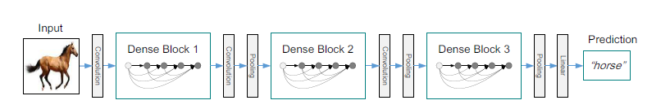

fig. 6 A deep DenseNet with three dense blocks. The layers between two adjacent blocks are referred to as transition layers and change feature-map sizes via convolution and pooling

#### DenseNet Architecture

##### Dense Block

A dense block assembled of *n*dense layers, and the concept of dense connections has been portrayed in dense blocks giving each layer access to the input feature map and to the gradient loss function of all of its preceding. These dense layers are connected using a dense circuitry such that each dense layer receives feature maps from all preceding layers and passes it’s feature maps to all subsequent layers, while preserving the features map scales the same.

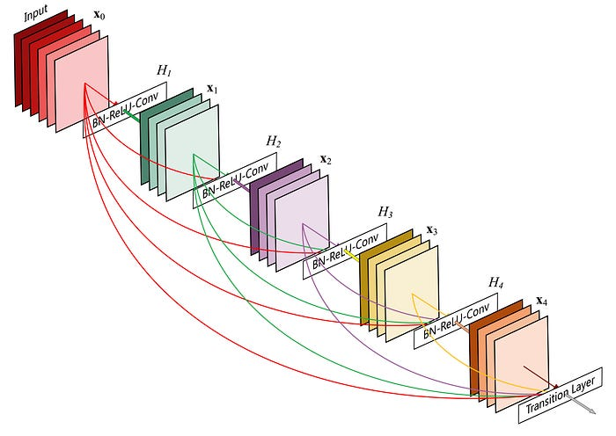

fig. 7 A 5-layer dense block with a growth rate of k = 4. Each layer takes all preceding feature-maps as input.

The output of the dense block has a grow rate (k) which is the number of the output channels by a dense layer that concatenated and fed as the input to the next dense layer. At the end of each dense block, the number of feature-maps accumulates to a value of — *input features + (number of dense layers x growth rate).*

##### Composite function

In some DenseNet architectures each conv layer includes the corresponding operation of BatchNorm→ ReLU→ Conv.

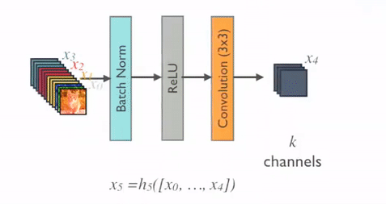

fig. 8 composite function

##### Transition Layer (pooling layer)

Transition layers are used to downsample feature maps and adjust the number of channels between 2 dense blocks. They typically include a combination of 1x1convolutions for dimensionality reduction and 2X2 average pooling for downsampling.

##### Bottleneck layer

DenseNet often uses bottleneck layers to reduce computational complexity. These layers consist of 1x1convolutions that reduce the number of input channels before applying 3x3 convolutions. This helps in reducing the number of parameters and computational cost without sacrificing the learning capability.

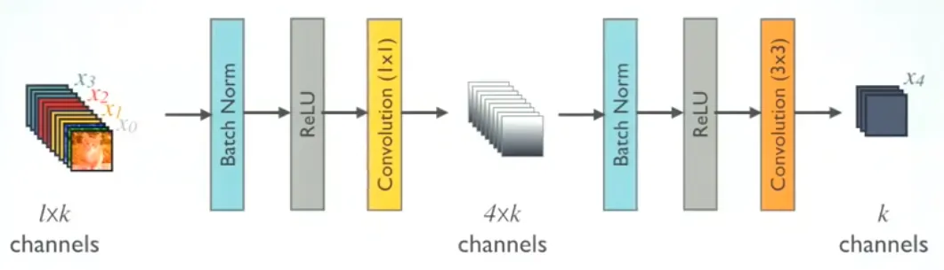

fig. 9 DenseNet with a Bottleneck layer

##### Compression

Compression is used to further improve model compactness by reducing the number of feature maps at transition layers. If a dense block contains m feature maps, the following transition layer generates $\left\lfloor θm\right\rfloor$ output feature maps, where $0<θ<1$ is the compression factor. A compression factor of $θ=1$ means the number of feature maps remains unchanged across transition layers.

# Proposed approach

## Convolutional Layer

A 3x3 convolution utilizes a small filter that slides over the input image, effectively capturing local patterns like edges and textures, which are critical for identifying structures such as meniscal tears in MRI scans. The choice of 3x3 strikes a balance between computational efficiency and the ability to capture spatial relationships, allowing the model to learn complex patterns over successive layers. Additionally, DenseNet with ImageNet weights carries the input of 3 channel depth, while our MRI preprocessed data has a depth of 17. By applying 3x3 convolutions, we reduce the depth to 3 per plane, ensuring compatibility with the DenseNet architecture while preserving essential spatial information from the multi-plane MRI scans. This approach optimizes feature extraction and ensures efficient model performance.

## Batch Normalization

In our study using deep learning, Batch Normalization plays a crucial role in improving the stability and performance of the DenseNet model. By normalizing the input features within each mini-batch, Batch Normalization mitigates the internal covariate shift, where the distribution of each layer's inputs changes during training. This allows the model to converge faster and be less sensitive to the initial learning rate. Moreover, Batch Normalization acts as a regularizer, reducing the need for other forms of regularization like dropout, and it helps prevent overfitting, ensuring better generalization on unseen meniscus tear MRI data.

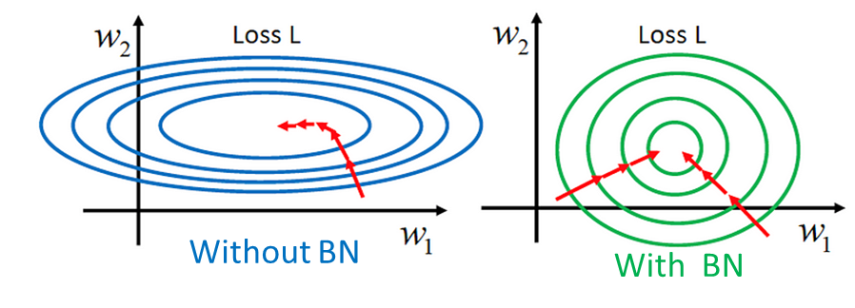

fig. 10 The effect of Batch Normalization on the training process.

## Transfer learning

Transfer learning is a subfield of machine learning that leverages knowledge from one or more source tasks to enhance learning in a related target task. Unlike traditional machine learning methods, which treat tasks independently and require separate models for every new task, transfer learning allows models to use previously acquired knowledge to improve performance and efficiency (fig. 11). This process involves extending various machine learning algorithms, such as neural networks, Bayesian networks, Markov Logic Networks, Q-learning, and policy search, to facilitate knowledge transfer. The benefits of transfer learning are measured through initial performance on the target task using only transferred knowledge, the speed at which the model learns the target task compared to starting from scratch, and the final performance level achieved. Similarly, to human learning, transfer learning aims to make machine learning more efficient by incorporating additional information from related tasks ‎[13].

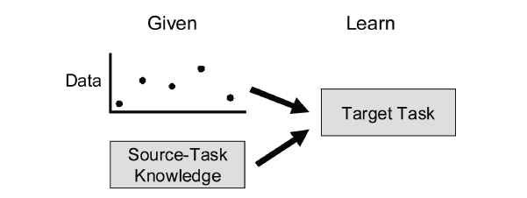

*fig. 11 Transfer learning is machine learning with an additional source of information apart from the standard training data: knowledge from one or more related tasks.*

By utilizing a pre-trained DenseNet121 architecture, trained on the large-scale ImageNet dataset, we can efficiently transfer the model's learned knowledge of general image features to our classification imaging task.

## Network architecture

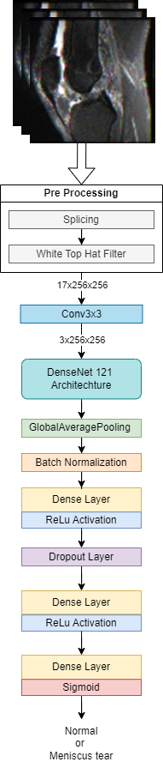This study consists of 2 main models: 1) Single-plane model, 2) Two-planes model. These 2 architectures based on DenseNet-121 backbone and aim for detecting a meniscal tear and tested different approaches.

### Single-Plane Model

The initial phase of the model involves several pre-processing steps aimed at preparing the MRI slices for feature extraction. Each MRI scan is first **spliced** into a three-dimensional array with a fixed depth, width, and height of $s×256×256×17$. Following this, a **white top-hat filter** is applied to each slice, where $s$ is the number of images for the input.

The images are passed into a 3x3 convolutional layer is applied to each slice, reducing the depth to a manageable size while preserving spatial information, resulting in a tensor of dimensions $s×256×256×3$ (3 represent the RGB number). The processed data is then fed into the **DenseNet 121** architecture, which acts as the feature extraction backbone. After feature extraction, **2D Global Average Pooling** is applied to reduce the spatial dimensions of the output. The feature vector output from the Global Average Pooling layer is then passed through a series of fully connected layers to perform the final classification. First, a **Batch Normalization** Layer is applied to normalize the feature vector, which helps in accelerating the training process and improving convergence stability. The normalized features are then passed through two **Dense Layers**, the first one followed by a **ReLU Activation** function and a **Dropout Layer**, while the second followed only by ReLU Activation. The dropout layer, with a specified dropout rate, prevent overfitting by randomly setting a fraction of the input units to zero during training, thus promoting generalization of the model.

Finally, the last dense layer employs a **Sigmoid Activation Function** to output a single probability value between 0 and 1, indicating the likelihood of a meniscus tear being present in the MRI scan.

a similar model to the single plane model was trained for the data set that were preprocessed for the middle 3 slices, without the convolutional layer, directly to the DenseNet, this architecture was tested in 3 different forms, DenseNet, with transfer learning and with transfer learning and batch normalization.

fig. 12 Single-Plane model architecture

### 2 Planes Concatenation Model

fig. 13 Two-Planes model architecture

The two-plane model shares the same initial architecture as the single-plane model, incorporating identical pre-processing and feature extraction steps for each plane independently. Specifically, for both the sagittal and coronal planes, the MRI slices undergo and identical pre-processing steps. After pre-processing, a $3×3$ convolutional layer is employed to reduce the depth to 3 slices, producing tensors of dimensions $s×256×256×3$. Each plane's processed data is then fed separately into a **DenseNet-121** architecture, followed by Global Average Pooling. Once feature extraction is completed for both planes, the model architecture diverges from the single-plane.

This concatenation step merges the spatial features extracted from both planes into a unified, comprehensive feature vector that encapsulates anatomical and pathological information from both orientations. The concatenated feature vector is then passed through a Batch Normalization layer to standardize the feature distribution. After normalization, the data passes through two fully connected Dense Layers, with ReLU activations for non-linearity. A Dropout Layer follows the first Dense Layer to prevent overfitting during training. Finally, the last Dense Layer used to produce a probability score as the same as the Single-Plane model.

#### 3 Plane Concatenation model

A similar architecture to the two planes model was tested upon 3 planes, this model was incorporate a similar architecture but without the convolutional layer due to the fact that it was trained with the 3 middle slices of each scan.

## Hyperparameters

**Researched hyperparameters** in our model are:

### Single-Plane Model

* Learning rate {${5⋅{10}^{-3},10}^{-3}$, $5⋅{10}^{-4},5⋅{10}^{-5}$}
* Epochs {50, 100,150}
* Batch size {16, 32, 64, 128}[1]
* Dropout Rate- 0.2, 0.4, 0.5

# Research process

The research process for this project was divided into two main phases: the training phase and the prediction phase, trying to optimized meniscus tear detection.

The process began with the acquisition and pre-processing of MRI images. This step was essential for standardizing the data and improving the clarity of relevant features. Pre-processing included operations like resizing the MRI images to ensure uniformed input and enhancing contrast through applying white top hat filter. This created a consistent dataset ready for model training.

## Training Process

### The 3 middle slices input approach

In the first stage of model development, a DenseNet model was trained on individual MRI planes, specifically the coronal, sagittal, and axial views. The idea was to assess how well each plane on its own could provide sufficient information for detecting a tear. The experiments were structured to identify which plane offered the most significant predictive performance, ensuring that only the most relevant data was used in later stages.

We trained the single plane DenseNet model without pre-trained weights and with imagenet weight to asses which plane is more sufficient and also whether the model performance is better with imagenet weights.

Next, the same DenseNet model was trained again on each of the three planes, but this time with Batch Normalization (BN) layers included. Batch Normalization was added to stabilize and accelerate learning by normalizing the activations within the network, thus allowing the model to generalize better. Following these training iterations, the best-performing plane was selected for further fine-tuning.

At this point, fine-tuning of hyperparameters was carried out on the chosen plane—coronal, in this case. The learning rate, dropout rate, and other important hyperparameters were adjusted through rigorous experimentation to improve the model’s performance. By focusing on the coronal plane, which had demonstrated the best predictive accuracy thus far, the fine-tuning phase aimed to further refine the model and achieve higher generalization on unseen data.

In addition to the single-plane models, a more complex architecture was developed, which utilized images from all three planes (coronal, sagittal, and axial). This model, referred to as the 3-plane concatenation model, was trained by concatenating the feature maps from each individual plane into a unified representation. The goal was to leverage the combined information from multiple perspectives to potentially enhance the model’s predictive accuracy. Once again, hyperparameter tuning was applied to this concatenation model to optimize its performance and mitigate any overfitting issues.

Upon completing the training and fine-tuning steps, the best-performing models were saved for deployment in the prediction phase. This ensured that the models were ready for inference on new MRI data.

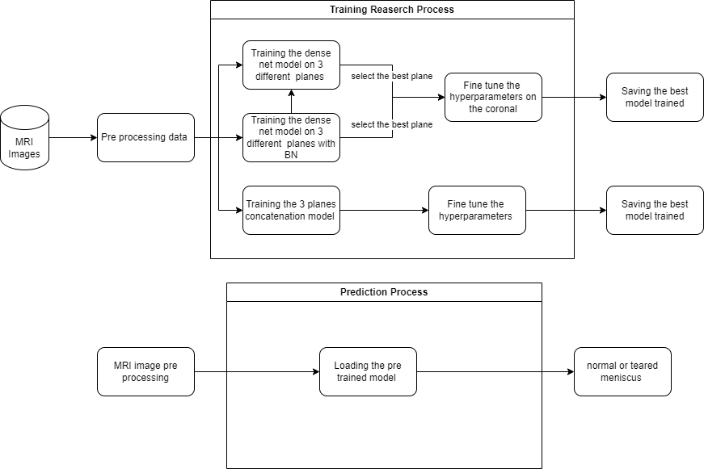

fig. 14 training process flow for the 3 depth input

### The 17 middle slices approach

MRI images were preprocessed to a uniform shape of (256, 256, 17), capturing 17 slices per scan to provide comprehensive spatial information of the meniscus region. This extended depth aimed to include more anatomical context, reducing overfitting observed when using fewer slices. Expanding from 3 to 17 slices allowed the model to better capture variations in meniscus appearance across different sections, mitigating overfitting.

The single plane model was trained on individual MRI planes (either coronal or sagittal) to evaluate the predictive power of each plane separately.

The 2-planes model combined information from the coronal and sagittal planes, integrating features from both perspectives to enhance classification performance. The axial plane was excluded to reduce computational complexity as it did not significantly contribute to model accuracy.

Both models underwent extensive hyperparameter optimization, including adjustments to learning rate, dropout rate, and batch size, to maximize performance and generalization considering the best performance from the 3 middle slices approach. The best-performing configurations of both models were saved for deployment and further analysis.

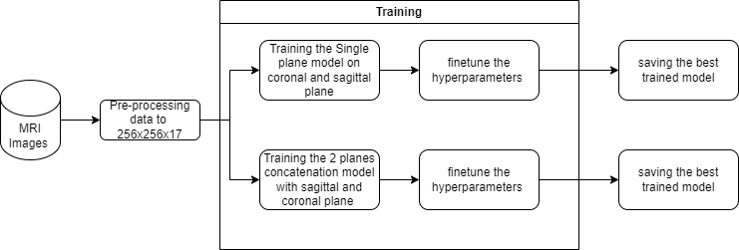

fig. 15 The diagram outlines the workflow for developing and training two deep learning models using MRI images: a Single-Plane model and a Two-Plane concatenation model.

## Prediction

In the prediction phase, the pre-trained models were loaded, and new MRI images were subjected to the same pre-processing steps as in the training phase, ensuring consistency in input data. These pre-processed images were then passed through the trained models to classify whether a meniscus tear was present or not, effectively categorizing each case as either a normal or torn meniscus.

# Results

In this part we will review the results of the single plane model with the batch normalization layer( table1) and the 3 planes concatenation model optimization of hyperparameters, we started with the middle values from each and select of each the best one. Then we tested the approach of 17 slice depth of each patient using the fine-tuned hyperparameters that we tested on the previous approach.

|  |  |  |  |  |
| --- | --- | --- | --- | --- |
| Sagittal plane | | | | |
| Model | Loss | Accuracy | Precision | Recall |
| D | 0.690469 | 0.566667 | 0.566667 | 0.566667 |
| DTF | 0.829713 | 0.5 | 0.5 | 0.525 |
| DTFBN | 0.962045 | 0.55 | 0.55 | 0.55 |
| Coronal plane | | | | |
| Model | Loss | Accuracy | Precision | Recall |
| D | 0.700151 | 0.566667 | 0.566667 | 0.566667 |
| DTF | 0.772429 | 0.529167 | 0.529412 | 0.525 |
| DTFBN | 0.789293 | 0.579167 | 0.581197 | 0.566667 |
| Axial plane | | | | |
| Model | Loss | Accuracy | Precision | Recall |
| D | 0.684892 | 0.566667 | 0.566667 | 0.566667 |
| DTF | 0.894425 | 0.483333 | 0.483333 | 0.483333 |
| DTFBN | 0.985041 | 0.491667 | 0.491525 | 0.483333 |

Table 1 Performance of Deep learning models; D stands for DenseNet; TF for Transfer Learning with imagenet weights; BN for Batch normalization layer; all models were trained with the input of 256x256x3 without the conv layer.

In Table 2 we can see that the single coronal plane predicts the tear more accurately, and performed better results.

|  |  |  |  |  |
| --- | --- | --- | --- | --- |
| Model | Loss | Accuracy | Precision | Recall |
| 3 Planes DTFBN | 0.715111 | 0.5625 | 0.57732 | 0.466667 |
| Coronal DTFBN | 0.789293 | 0.579167 | 0.581197 | 0.566667 |

Table 2 Comparation of performance of Deep learning models; Comparing the 3 planes concatenation model with the single plane model results. 3 Planes Concatenation DTFBN hyperparameters: Epochs: 100, Dropout: 0.4, Learning rate: $5e^{-5}$, Batch size: 32. Coronal DTFBN hyperparameters: Epochs: 100, Dropout: 0.4, Learning rate: $5e^{-4}$, Batch size: 32

## Single plane model

Choosing the best plane for the single plane model:

|  |  |  |  |
| --- | --- | --- | --- |
| Plane | Axial | Coronal | Sagittal |
| Optimizer | SGD | SGD | SGD |
| Loss function | Binary cross Entropy | Binary cross Entropy | Binary cross Entropy |
| Learning Rate | $$5⋅{10}^{-4}$$ | $$5⋅{10}^{-4}$$ | $$5⋅{10}^{-4}$$ |
| Epochs | 100 | 100 | 100 |
| Batch Size | 32 | 32 | 32 |
| Image Size | 256X256X3 | 256X256X3 | 256X256X3 |
| Dropout | 0.4 | 0.4 | 0.4 |
| Accuracy | 0.4967 | 0.55 | 0.5583 |
| Loss | 1.1278997402246729 | 0.8280065791315716 | 0.99692374886797 |

Table 3

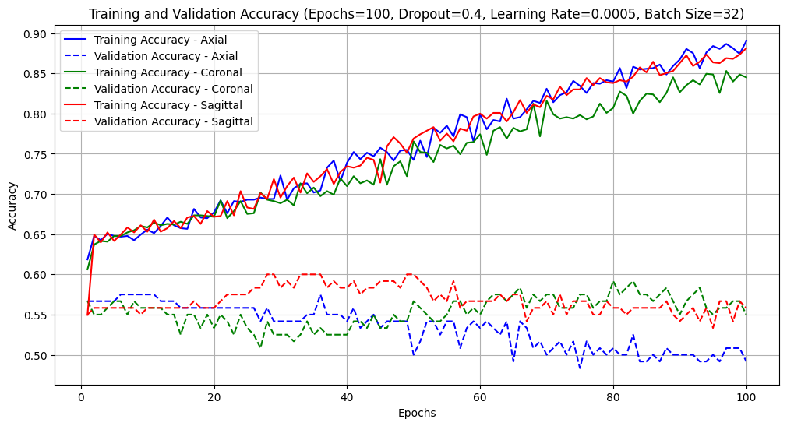

fig. 16 planes comparation accuracy of traning and validation

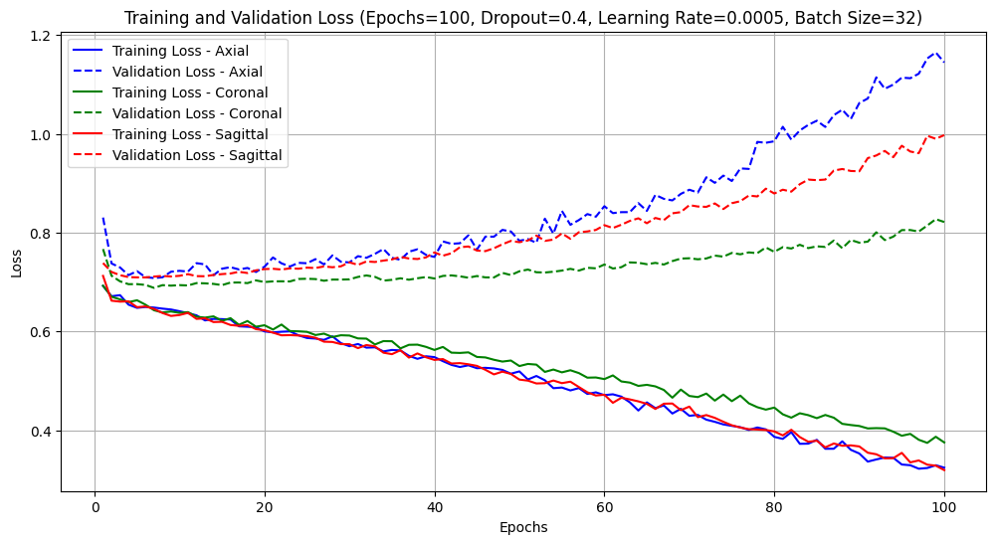

fig. 17 planes comparation loss of traning and validation

## Optimizing Hyperparameters on the most efficient plane

Reviewing the results of the 3 different planes tested on the models, the coronal plane beneficial the best results, choosing this plane for continuing fine tune hyperparameters.

### Learning Rate

|  |  |  |  |  |
| --- | --- | --- | --- | --- |
| Plane | Coronal | Coronal | Coronal | Coronal |
| Optimizer | SGD | SGD | SGD | SGD |
| Loss function | Binary cross Entropy | Binary cross Entropy | Binary cross Entropy | Binary cross Entropy |
| Learning Rate | $$5⋅{10}^{-3}$$ | $$1⋅{10}^{-3}$$ | $$5⋅{10}^{-4}$$ | $$5⋅{10}^{-4}$$ |
| Epochs | 100 | 100 | 100 | 100 |
| Batch Size | 32 | 32 | 32 | 32 |
| Image Size | 256X256X3 | 256X256X3 | 256X256X3 | 256X256X3 |
| Dropout | 0.4 | 0.4 | 0.4 | 0.4 |
| Accuracy | 0.575 | 0.625 | 0.575 | 0.55833 |
| Loss | 2.32664678981306 | 1.140588628832348 | 0.77785098627774 | 0.718576648787 |

Table 4

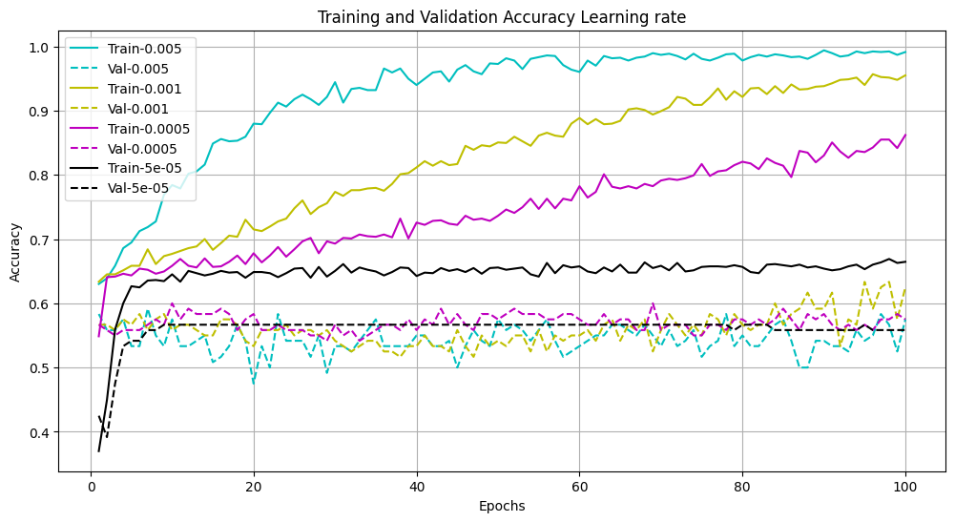

fig. 18 Reviewing the results, we notice that 0.001 has the most efficient accuracy learning the Loss graph informs that the model suffers from overfitting, by the seeing the validation loss increases drastically from epoch 80 stimulatingly the accuracy results increases as well.

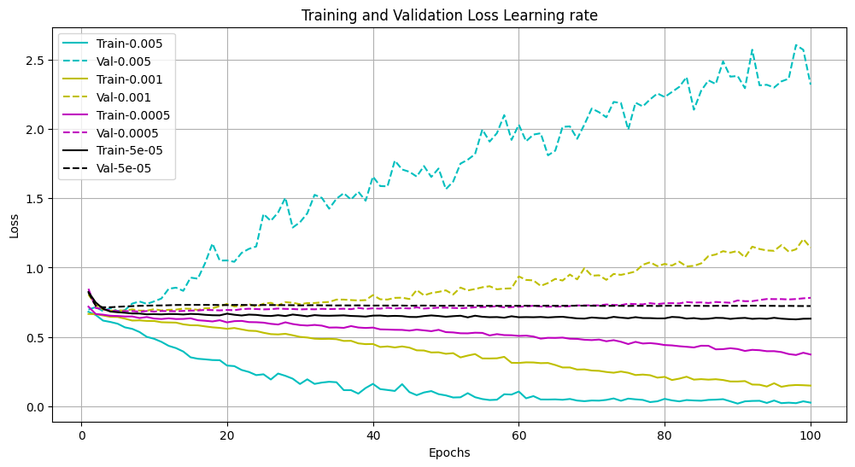

fig. 19 different learning rates loss comparation

### Dropout

|  |  |  |  |
| --- | --- | --- | --- |
| Plane | Coronal | Coronal | Coronal |
| Optimizer | SGD | SGD | SGD |
| Loss function | Binary cross Entropy | Binary cross Entropy | Binary cross Entropy |
| Learning Rate | $$5⋅{10}^{-4}$$ | $$5⋅{10}^{-4}$$ | $$5⋅{10}^{-4}$$ |
| Epochs | 100 | 100 | 100 |
| Batch Size | 32 | 32 | 32 |
| Image Size | 256X256X3 | 256X256X3 | 256X256X3 |
| Dropout | 0.2 | 0.4 | 0.5 |
| Accuracy | 0.6 | 0.59167 | 0.55833 |
| Loss | 0.8411133735677353 | 0.7870813125466419 | 0.7579238372906644 |

Table 5

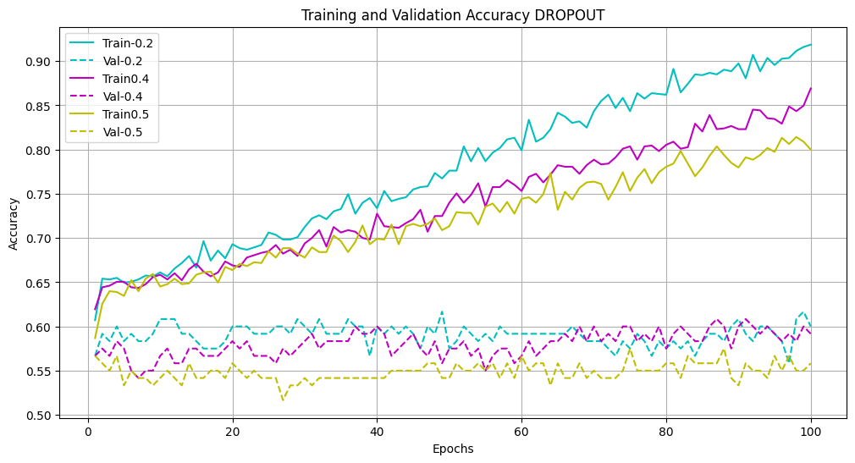

fig. 20 drop out comparation accuracy of traning and validation

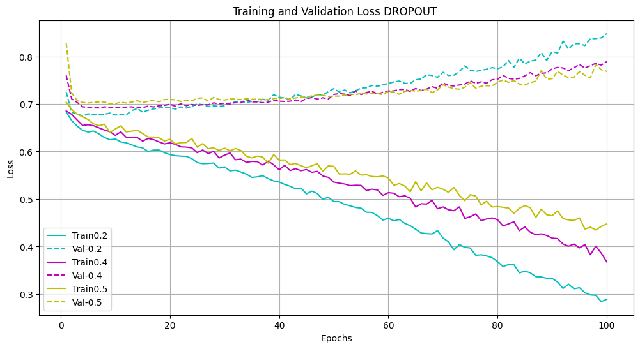

fig. 21 drop out comparation loss of traning and validation -here we can notice that the 0.2 dropout suffers from overfitting

## 3 planes concatenation DenseNet model

### Learning rate

|  |  |  |  |
| --- | --- | --- | --- |
| Optimizer | SGD | SGD | SGD |
| Loss function | Binary cross Entropy | Binary cross Entropy | Binary cross Entropy |
| Learning Rate | $$5⋅{10}^{-3}$$ | $$5⋅{10}^{-4}$$ | $$5⋅{10}^{-5}$$ |
| Epochs | 100 | 100 | 100 |
| Batch Size | 32 | 32 | 32 |
| Image Size | 256X256X3 | 256X256X3 | 256X256X3 |
| Dropout | 0.4 | 0.4 | 0.4 |
| Accuracy | 0.58 | 0.54 | 0.575 |
| Loss | 3.981200512326967 | 1.8208790633892304 | 1.0148664706322854 |

Table 6

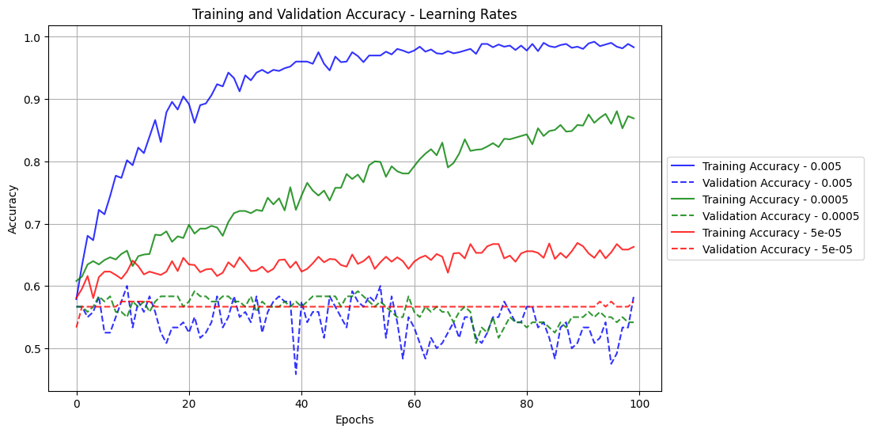

fig. 22 learning rates comparation accuracy of traning and validation of 3-planes model

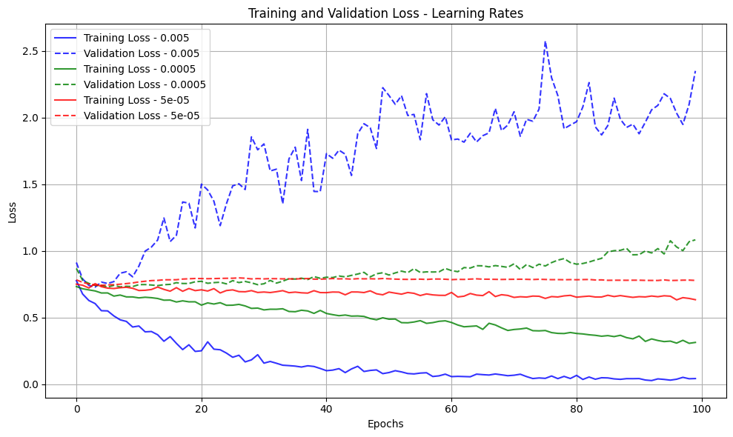

fig. 23 learning rates comparation loss of traning and validation of 3-planes model

### Dropout

|  |  |  |  |
| --- | --- | --- | --- |
| Optimizer | SGD | SGD | SGD |
| Loss function | Binary cross Entropy | Binary cross Entropy | Binary cross Entropy |
| Learning Rate | $$5⋅{10}^{-4}$$ | $$5⋅{10}^{-4}$$ | $$5⋅{10}^{-4}$$ |
| Epochs | 100 | 100 | 100 |
| Batch Size | 32 | 32 | 32 |
| Image Size | 256X256X3 | 256X256X3 | 256X256X3 |
| Dropout | 0.2 | 0.4 | 0.5 |
| Accuracy | 0.522 | 0.54 | 0.52 |
| Loss | 2.8817706325502104 | 1.798230279222065 | 1.2000513650177822 |

Table 7

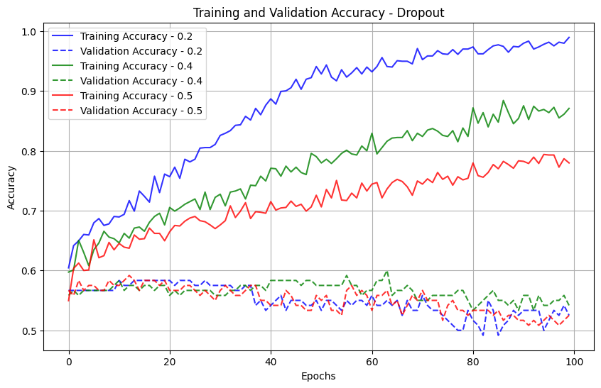

fig. 24 dropout comparation accuracy of traning and validation of 3-planes model

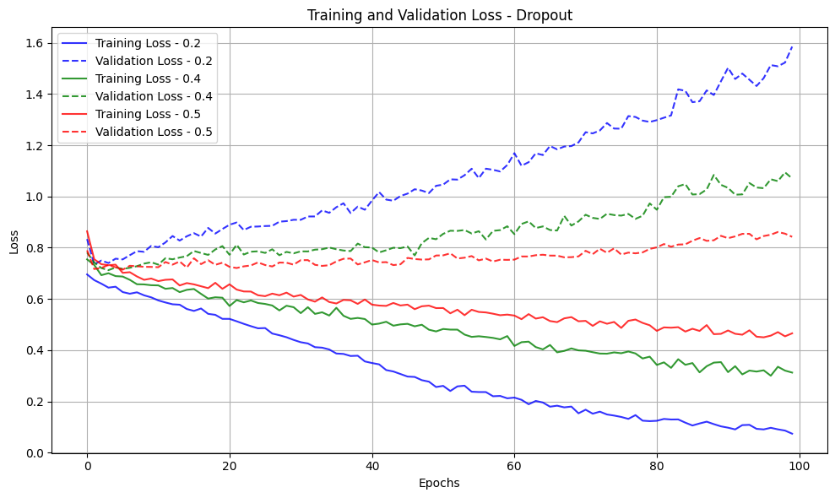

fig. 25 dropout comparation loss of traning and validation of 3-planes model

## Single plane model with convolution layer

**Batch size 128**

|  |  |  |  |  |  |  |  |  |
| --- | --- | --- | --- | --- | --- | --- | --- | --- |
| plane | epochs | dropout | batch size | Learning rate | accuracy | log loss | precision | recall |
| coronal | 50 | 0.5 | 128 | 5.00E-04 | 0.591667 | 0.69153 | 0.8 | 0.076923 |
| sagittal | 50 | 0.5 | 128 | 5.00E-04 | 0.591667 | 0.70362 | 0.636364 | 0.134615 |

Table 8 comparation of coronal and sagittal plane with the single plane model with convolution layer with batch size on 128

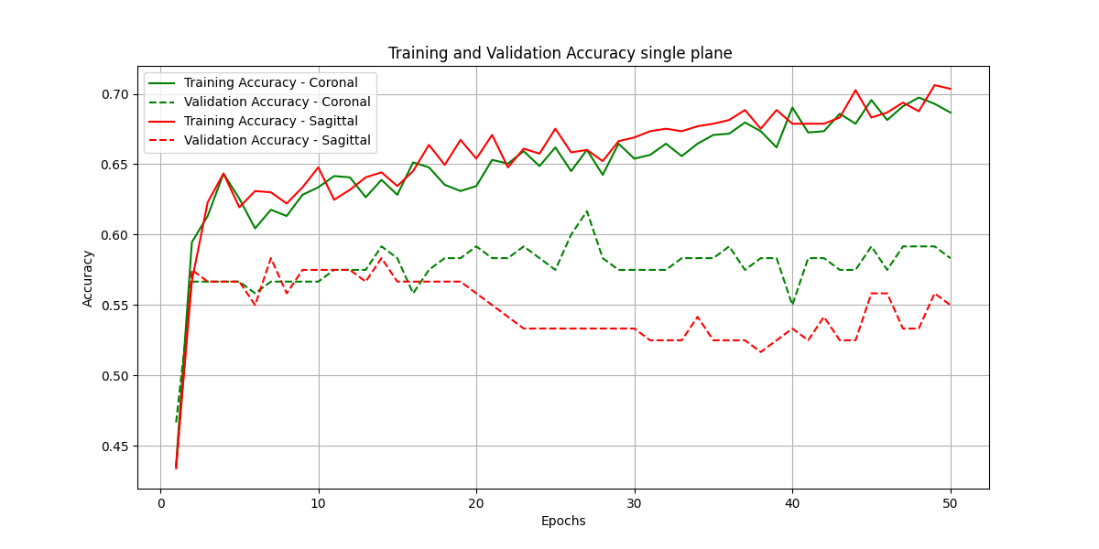

fig. 26 accuracy comparation of coronal and sagittal plane with the single plane model with convolution layer with batch size on 128

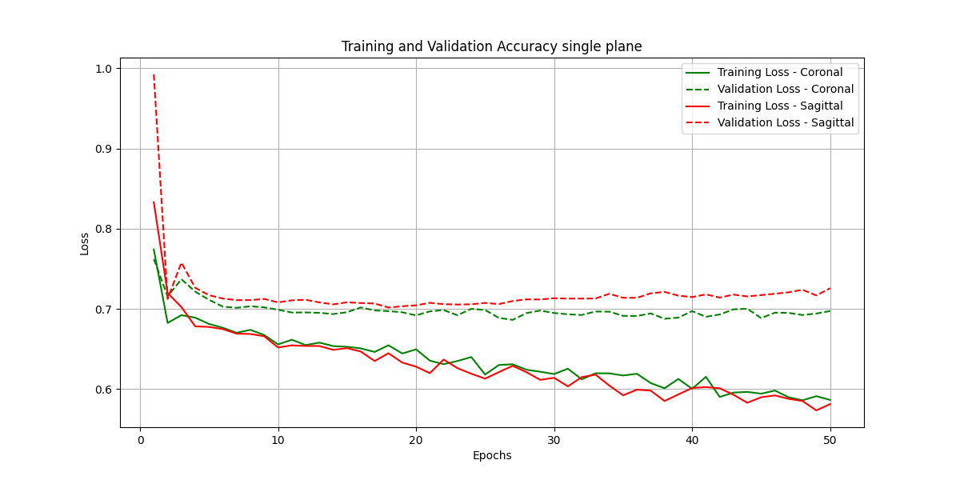

fig. 27 loss comparation of coronal and sagittal plane with the single plane model with convolution layer with batch size on 128

**Batch size 128**

|  |  |  |  |  |  |  |  |  |
| --- | --- | --- | --- | --- | --- | --- | --- | --- |
| plane | epochs | dropout | batch size | Learning rate | accuracy | log loss | precision | recall |
| coronal | 50 | 0.4 | 64 | 5.00E-04 | 0.56667 | 0.73623 | 0.5 | 0.173077 |
| sagittal | 50 | 0.4 | 64 | 5.00E-04 | 0.51667 | 0.75963 | 0.35 | 0.134615 |

Table 9 comparation of coronal and sagittal plane with the single plane model with convolution layer with batch size on 64

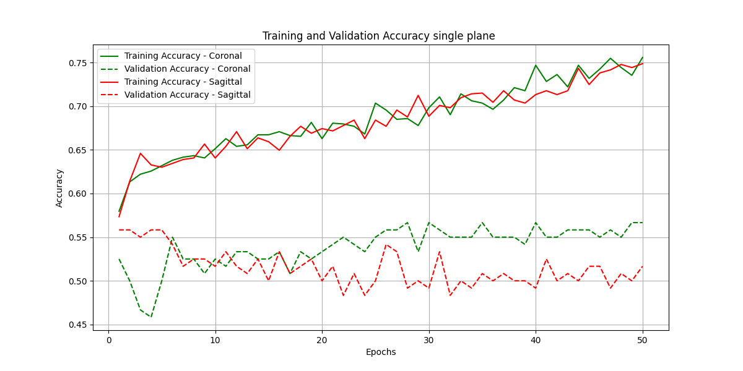

fig. 28 accuracy comparation of coronal and sagittal plane with the single plane model with convolution layer with batch size on 64

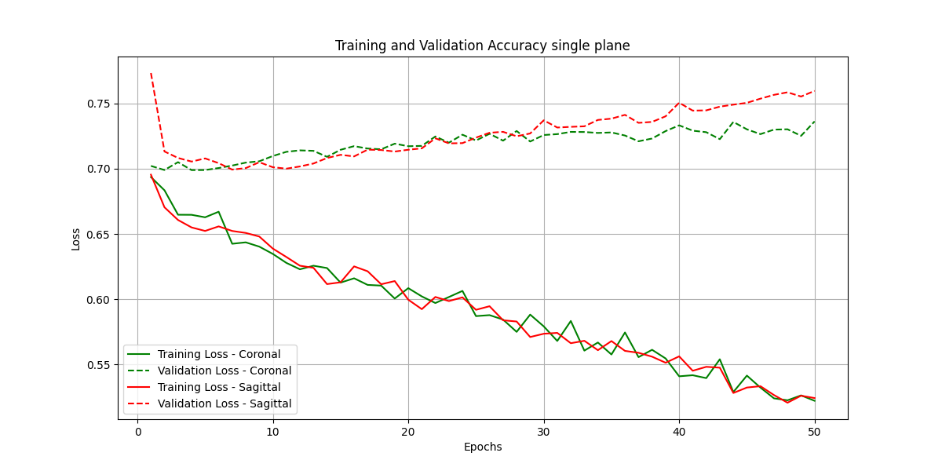

fig. 29 loss comparation of coronal and sagittal plane with the single plane model with convolution layer with batch size on 64

## 

## 2 planes concatenation DenseNet model with convolution layer

|  |  |  |  |  |  |  |  |
| --- | --- | --- | --- | --- | --- | --- | --- |
| epochs | dropout | batch size | Learning rate | accuracy | log loss | precision | recall |
| 50 | 0.4 | 32 | 5.00E-04 | 0.616667 | 0.711451 | 0.625 | 0.288462 |
| 50 | 0.4 | 64 | 5.00E-04 | 0.533333 | 0.703925 | 0.4 | 0.153846 |

Table 10 comparation of batch size on the 2-planes model with the sagittal and coronal plane

**Batch size 32**

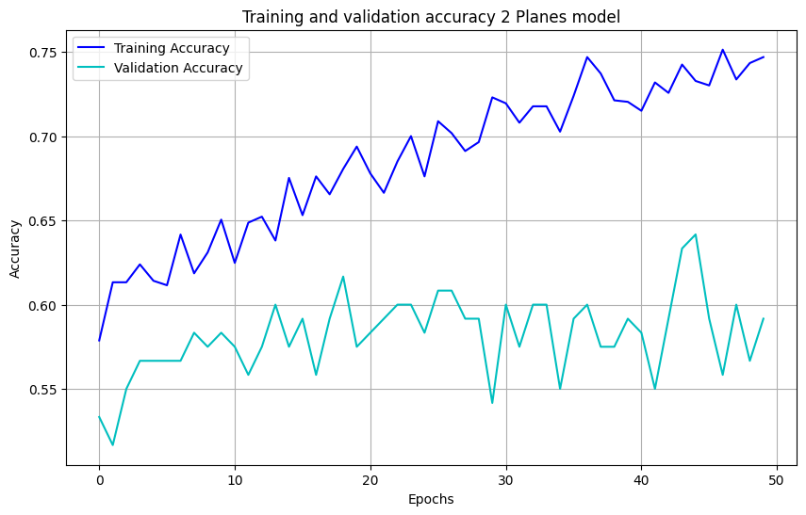

fig. 30 accuracy with batch size=32

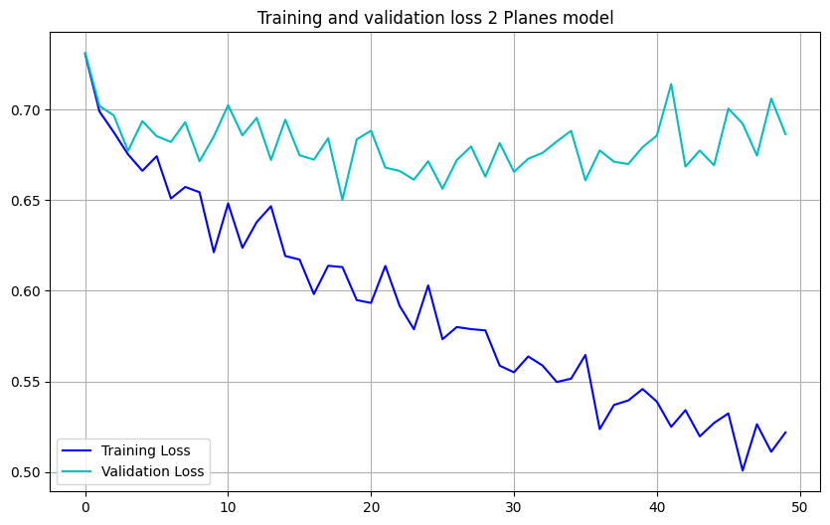

fig. 31 loss with batch size=32

**Batch size 64**

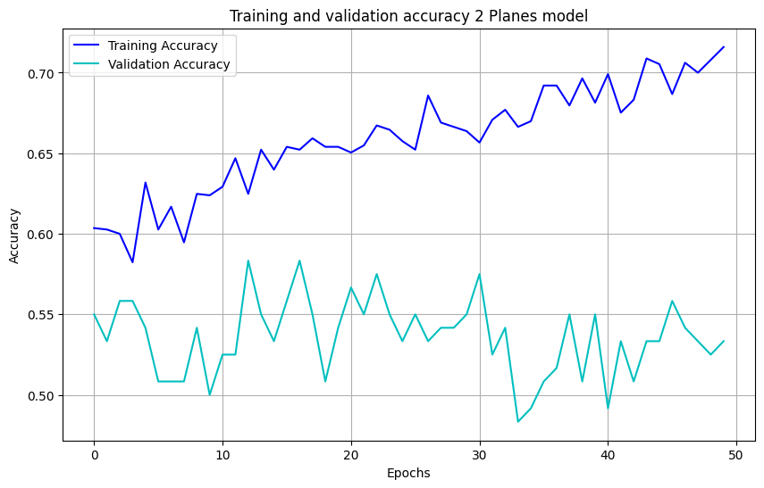

fig. 32 accuracy with batch size=64

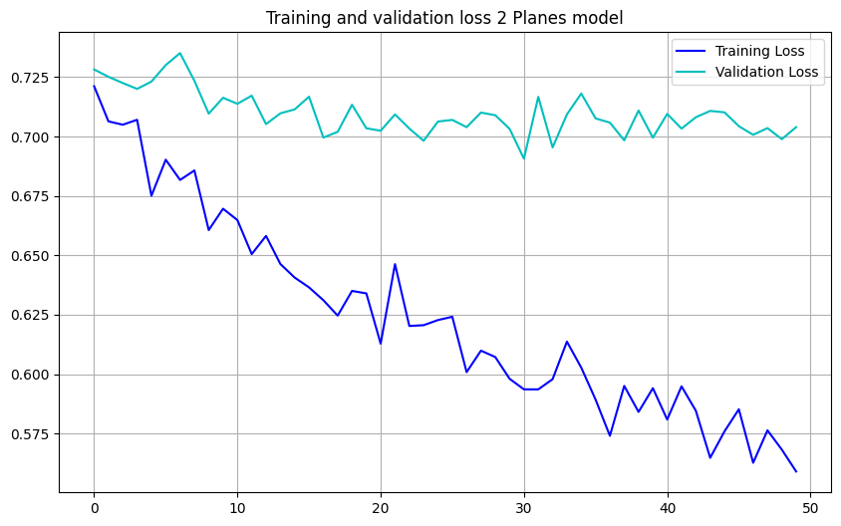

fig. 33 loss with batch size=64

# Discussion

This study aimed to develop an automated deep learning model for detecting meniscus tears in knee MRI images, leveraging the DenseNet architecture. Several models were explored and fine-tuned to optimize performance. Despite advancements, challenges and limitations were encountered, impacting the final results.

A significant component of this research involved evaluating different model architectures. Two principal architectures were tested: a single-plane DenseNet model and a 3-plane concatenation DenseNet model. The single-plane model analyzed MRI images from individual planes (coronal, sagittal, or axial), while the 3-plane model concatenated features from all three planes. Results indicated that the single-plane model outperformed the 3-plane concatenation model, with the coronal plane yielding the highest accuracy of 59% when combined with batch normalization and optimized hyperparameters. In contrast, the 3-plane model attained an accuracy of 56%, suggesting that the single-plane approach was more effective in this context. The Single-Plane model processes one plane at a time, focusing on a simpler representation of spatial information.

Another perception was implemented to improve the model's performance. Instead of using a 3-plane model, a 2-plane model was introduced, utilizing only the coronal and sagittal planes. The axial plane was excluded as it was found to be less effective in detecting meniscus tears and added unnecessary computational complexity. In contrast, the new 2-Plane model integrates features from the coronal and sagittal planes, combining different perspectives into a unified feature vector, thus increasing the model’s spatial awareness while maintaining efficiency.

The MRI slice depth also played a crucial role in model performance. Initially, three central slices were used per scan assuming the meniscus is visible. This approach resulted in better recall, as the model could identify tears when present. However, it also led to overfitting due to the limited input and the uncertainty in the visibility of the lesion area, causing the model to perform well on training data but poorly on unseen data. To mitigate this, the input depth was expanded to 17 slices per scan, aiming to capture more extensive anatomical information. The depth of the slices size was chosen by excreting the minimum size of the depth from each plane while preprocess it each plane slice vary in the range of (17,59) per plane of a patient. Although this change reduced overfitting, it significantly lowered recall scores, as the model classified most cases as non-tear. This was likely because the additional slices did not always include the lesion, diluting the learning signal and reducing the model's sensitivity to tears.

In the two different depths for the MRI images tested, the single-plane model demonstrated a stable learning trend during training compared to the multi-plane models. In order to manipulate different depth, through the models input a convolutional 3x3 layer to extracts features of the input and adjusting it to the DenseNet constrained input.

These findings underscore the importance of a well-classified dataset where the meniscus is clearly visible in all slices used for training. A targeted approach, focusing on slices where the meniscus is prominently visible, would likely improve recall and overall classification performance. Precising the dataset to include more cases and ensuring precise labelling would also contribute to more accurate model training and better generalization to new data.

Despite these optimizations, the model's performance was constrained by percentage of the visible lesson in the slices that were selected from the MRNet dataset, while commonly used, lacked sufficient data diversity and precise annotations to fully train a model capable of generalizing to unseen data. Enhancing the dataset with more cases, well-annotated slices focusing on the meniscus, and data augmentation techniques to increase the effective size of the training set would likely improve the model's performance.

While transfer learning was successfully employed by fine-tuning a pre-trained DenseNet model originally trained on the ImageNet dataset, further refinement is necessary to optimize its performance for medical imaging tasks. Additionally, exploring ensemble methods or other advanced architectures may enhance the model’s accuracy by combining the strengths of multiple learning approaches.

To further enhance the interpretability and clinical applicability of the model, Grad-CAM (Gradient-weighted Class Activation Mapping) was proposed as a technique for visualizing which regions of the MRI images contribute most to the model’s decision-making process‎[7]‎. Additional method is YOLO for bounding box the meniscus area so the training process will be more efficient‎[6].

# Conclusion

In conclusion, this study demonstrates that the single-plane DenseNet model provided superior results compared to the 3-plane concatenation model for detecting meniscus tears. The new two-plane approach, has the potential to further improve performance. Additionally, the incorporation of a Conv2D layer in the single-plane model, after selecting 17 slices per scan, enabled better feature extraction and improved learning capacity. However, significant room for improvement remains, particularly through the use of a more comprehensive and accurately annotated dataset. Future research should focus on addressing these limitations and identifying the meniscus area during the training phase.

# User Guide

### Introduction

The Meniscal Tear Classification System is a deep learning-based platform designed to classify meniscal tears in knee MRI scans. The system uses the MRNet dataset from Stanford University Medical Center, which includes MRI scans taken from three different planes: coronal, sagittal, and axial. The classification system was developed using Google Colab Pro+, and the model is trained on MRI slices of the knee. This guide provides step-by-step instructions for loading the model, preprocessing the data, training, and making predictions. The main python libraries that were used are:

* Keras – for creating deep learning models.
* TenserFlow- the backend library used to run the deep learning models.
* Numpy - for handling and manipulating the MRI image data.

### Operating Instructions

To use our dataset, you need to mount our Google Drive. (After we shared the folder with you)

1. Select “Shared with me” on the side menu.
2. Go to the “meniscus data set” folder and open the menu.
3. Click on “Organize”.
4. Select “Add shortcut to Drive”.
5. Select “My Drive” and click “Add”.





## Preprocessing

This section is responsible for extracting middle MRI slices and applying preprocessing steps to enhance the images before they are used for training and validation in the meniscal tear classification model. We extract 3 middle slices from MRI scans, apply a white top hat filter to improve contrast and save the processed images to Google Drive. The dataset consists of two parts: training and validation sets, each organized by planes: coronal, sagittal, and axial.

We have already generated the preprocessed dataset, so running this section is optional. If you want to regenerate the dataset, you can follow the steps outlined below.

Steps for Preprocessing

1. Loading the MRI Data:
   * The dataset consists of MRI scans saved as .npy files. Each file contains about 30 slices for each plane (coronal, sagittal, axial).
   * We extract only the middle slices from each MRI scan, as they contain the most relevant information for detecting meniscal tears.
2. Applying the White Top Hat Filter:
   * The white top hat filter is applied to enhance the contrast in the MRI images.
3. Saving the Preprocessed Data:
   * After applying the filter, the MRI slices are saved as .npy files in the appropriate directories within Google Drive, specifically organized by the plane and dataset type (training or validation).

Running the Preprocessing Script

1. Open the Preprocessing Script classify_meniscal_tears_data_preprocess.ipynb
2. Delete Old Data (Optional):
   * If you wish to regenerate the dataset, delete the old pre-processed data or change the saving path first to avoid duplication. This is optional if you want to start fresh.
3. Run the Cells:
   * After selecting the parameters, execute each cell in order to load the MRI data, extract the middle slices, apply the white top hat filter, and save the processed images.

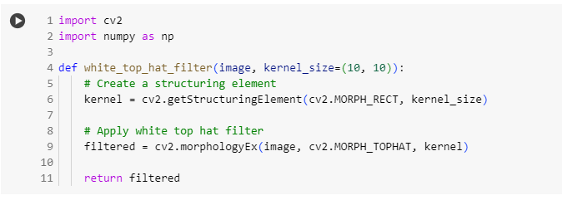

1. Generate the New Dataset:
   * Once the old data is deleted (if needed), generate the new dataset by running the script to process and save the MRI slices for training and validation sets.

Results

The pre-processed MRI slices are saved in the following directories:

* Training Data: /train_transformf/{plane}/
* Validation Data: /valid_transformf/{plane}/

Each folder contains subdirectories for the coronal, sagittal, and axial MRI planes. After preprocessing, these images can be used to train and validate the meniscal tear classification model.

## Training

This section explains how to train the Meniscal Tear Classification Model using MRI slices. To achieve optimal results, the model should be trained on a strong GPU, such as the NVIDIA A100 GPU available in Google Colab Pro+. Training without a GPU will be significantly slower or not working.

The training process involves selecting the appropriate hyperparameters, loading the training and validation data, and running the script. After training, the resulting model will be saved and can be used in the prediction section.

Define Hyperparameters:

* Before running the training, adjust the hyperparameters based on your dataset and model architecture.

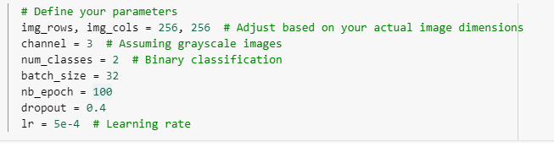

Load the Pre-processed Data:

* If you are using the provided pre-processed MRI data, ensure that it has been saved in the appropriate folders in Google Drive. If you have your own pre-processed data, ensure it is stored in Google Drive or another accessible location, and update the script to reflect the correct file paths.

The pre-processed data is organized into the following folders:

* Training data: /content/drive/My Drive/meniscus data set/MRNet-v1.0/train_transformf/<plane>
* Validation data: /content/drive/My Drive/meniscus data set/MRNet-v1.0/valid_transformf/<plane>

Where <plane> is one of coronal, sagittal, or axial.

## Predict

This section explains how to use the trained model to predict whether an MRI scan indicates a meniscal tear or not. The following steps describe how to load the trained model, preprocess the new MRI scan data, make predictions, and display the results.

The trained model has been saved in a .keras file and will be used to predict the presence of a meniscal tear in a new set of MRI slices.

Steps for Prediction

1. Open classify_meniscal_tears_predict.ipynb
2. Update the image path and the model path according to your image and the chosen model.



1. Load the Trained Model.

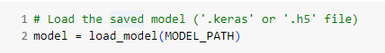

1. Preprocess the input image.

The input MRI scan is stored in .npy format, which contains about 30 slices. The next step involves extracting the middle slices of the MRI scan, normalizing the pixel values, and reshaping the data to fit the input format expected by the model.

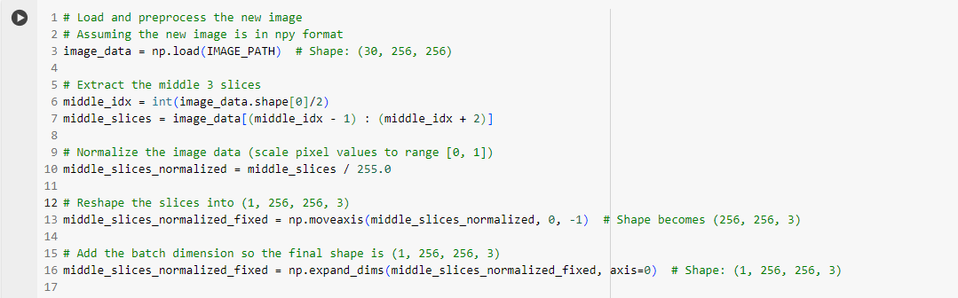

1. Make a Prediction.

With the model loaded and the MRI slices preprocessed, the next step is to use the model to predict whether the MRI scan indicates a meniscal tear.

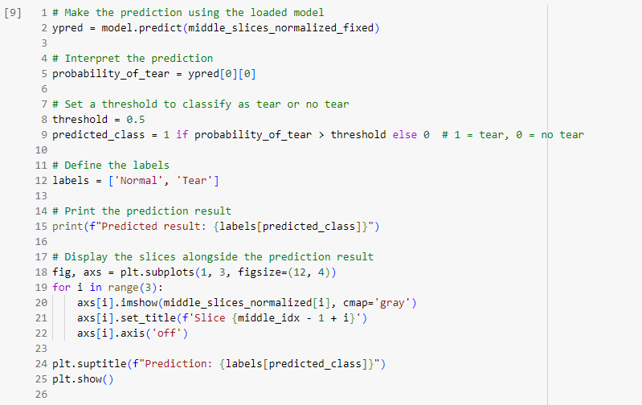

1. Display the Prediction.

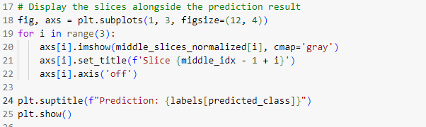

Example: 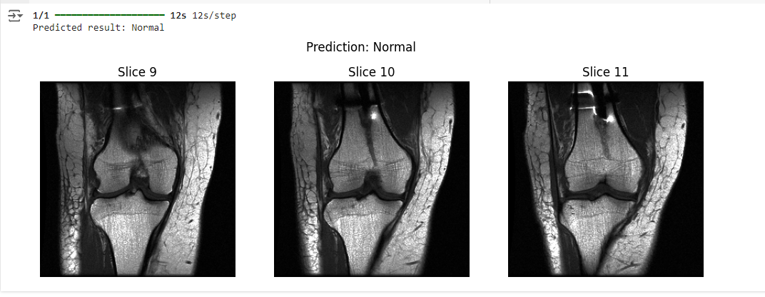

# Maintenance Guide

File and Data Management

To add new training data and preprocess it:

1. Obtain New MRI Scans:
   * Ensure that the new MRI scans are in .npy format or another format that your preprocessing script can handle.
2. Use the Preprocessing Script:
   * Open the data_preprocess.ipynb file and run the necessary cells to preprocess the new data.
   * This script will handle tasks such as extracting middle slices and saving the processed files to Google Drive.
3. Verify Processed Data:
   * Check that the preprocessed files are saved in the appropriate Google Drive folder as .npy files. The directory structure should follow:
     + /train_transformf/{plane}/
     + /valid_transformf/{plane}/
4. Update Training Script:
   * Ensure the training script references the correct paths to the newly preprocessed data stored on Google Drive.

Updating Prediction Input

To update the input data for making predictions using new MRI scans in .npy format:

1. Save the new input scan in your drive and update the path in the code.
2. Save the new model(.keras file) drive and update the path in the code.
   * Load the pre-trained model to use for making predictions.



1. Make Prediction.

## Future Development

Several potential improvements can be made to the meniscal classification system in future iterations:

1. Increase the Dataset
   * Continuously add new MRI scans to the dataset. A larger dataset will improve model generalization, leading to better performance.
2. Add GradCam for Model Visualization
   * Implement GradCam to visualize which areas of the MRI scan the model focuses on during classification. This can help ensure the model is focusing on the meniscus area.
3. Multi-class Tear Classification
   * Expand the system to classify specific tear types (e.g., radial, flap, horizontal) by modifying the model’s architecture and output layer.
4. DICOM/NIfTI to NumPy Conversion (Future Development)
   * Implement a feature that converts DICOM or NIfTI files to .npy format as part of preprocessing. This will streamline the handling of raw MRI scans in different formats.
5. 3D DenseNet Implementation
   * Consider moving to a 3D DenseNet architecture to handle the full 3D volume of MRI scans for improved performance on more complex tear cases.

# References

1. Andrews, S. H., Adesida, A. B., Abusara, Z., & Shrive, N. G. (2017). Current concepts on structure–function relationships in the menisci. Connective tissue research, 58(3-4), 271-281.‏
2. Smoak, J. B., Matthews, J. R., Vinod, A. V., Kluczynski, M. A., & Bisson, L. J. (2020). An up-to-date review of the meniscus literature: a systematic summary of systematic reviews and meta-analyses. Orthopaedic journal of sports medicine, 8(9), 2325967120950306.‏
3. Ghidotti, A', Regazzoni, D', & Weiss Cohen, M'. (2023). The Effect of Meniscal Tears on Knee Biomechanics. *The Effect of Meniscal Tears on Knee Biomechanics*, 1-5.
4. Fox, A. J., Bedi, A., & Rodeo, S. A. (2012). The basic science of human knee menisci: structure, composition, and function. Sports health, 4(4), 340-351.‏
5. Shin, H., Choi, G. S., Shon, O. J., Kim, G. B., & Chang, M. C. (2022). Development of convolutional neural network model for diagnosing meniscus tear using magnetic resonance image. BMC Musculoskeletal Disorders, 23(1), 510.‏
6. Hung, T. N. K., Vy, V. P. T., Tri, N. M., Hoang, L. N., Tuan, L. V., Ho, Q. T., ... & Kang, J. H. (2023). Automatic detection of meniscus tears using backbone convolutional neural networks on knee MRI. Journal of Magnetic Resonance Imaging, 57(3), 740-749.‏
7. Fritz, B., Marbach, G., Civardi, F., Fucentese, S. F., & Pfirrmann, C. W. (2020). Deep convolutional neural network-based detection of meniscus tears: comparison with radiologists and surgery as standard of reference. Skeletal radiology, 49, 1207-1217.‏
8. Nacey, N.C., Geeslin, M.G., Miller, G.W. and Pierce, J.L., 2017. Magnetic resonance imaging of the knee: An overview and update of conventional and state of the art imaging. Journal of Magnetic Resonance Imaging, 45(5), pp.1257-1275.
9. Couteaux, V., Si-Mohamed, S., Nempont, O., Lefevre, T., Popoff, A., Pizaine, G., ... & Boussel, L. (2019). Automatic knee meniscus tear detection and orientation classification with Mask-RCNN. *Diagnostic and interventional imaging*, *100*(4), 235-242.‏
10. Ghidotti, A., Cattaneo, A., Vitali, A., Regazzoni, D., & Rizzi, C. (2023). ACL Morsky: Semi-automatic Tool for Assessing the Risk of Developing an Anterior Cruciate Ligament Injury. COMPUTER-AIDED DESIGN AND APPLICATIONS, 20(4), 736-748.‏
11. Huang, G., Liu, Z., Van Der Maaten, L., & Weinberger, K. Q. (2017). Densely connected convolutional networks. In Proceedings of the IEEE conference on computer vision and pattern recognition (pp. 4700-4708).‏
12. Rikiya Yamashita, Mizuho Nishio, Richard Kinh Gian Do and Kaori Togashi, “Convolutional neural networks: an overview and application in radiology”, Insights into Imaging volume 9, pages 611–629 (2018).
13. Torrey, L., & Shavlik, J. (2010). Transfer learning. In Handbook of research on machine learning applications and trends: algorithms, methods, and techniques (pp. 242-264). IGI global.‏
14. Bien, N., Rajpurkar, P., Ball, R. L., Irvin, J., Park, A., Jones, E., ... & Lungren, M. P. (2018). Deep-learning-assisted diagnosis for knee magnetic resonance imaging: development and retrospective validation of MRNet. PLoS medicine, 15(11), e1002699.‏

1. The batches of 64 and 128 were tested on the single plane model alone.